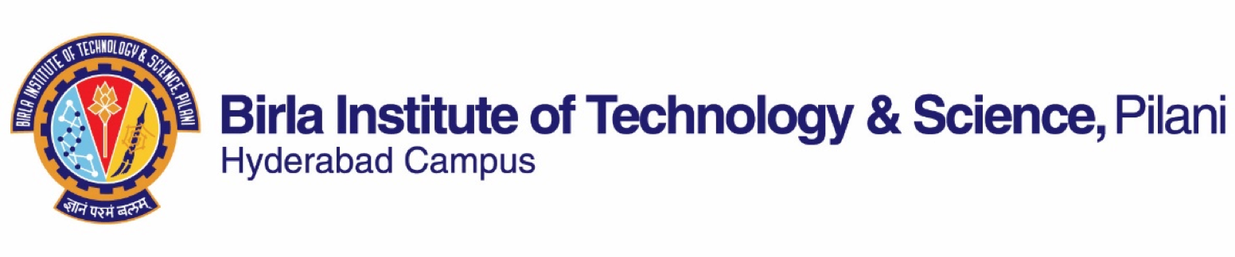
FIRST SEMESTER 2021-2022

Course Handout Part - II
01-08-2021

In addition to Part-I (General Handout for all courses appended to the time table) this portion gives further specific details regarding the course.

Course No.: BIO G514
Course Title: Molecular Immunology
Instructor-in-Charge: Dr. Trinath Jamma
Instructor: Dr. Trinath Jamma, K. Vaishali, Lokesh Kumar Sahoo, Nikhil P T

Description : This course will deal extensively with topics like molecular basis of T and B cell antigen recognition and activation. Immunity to microbes and diseases caused by humoral and cell mediated immune responses will be covered and emphasis placed on congenital and acquired immunodeficiencies. Advanced topics like antibody engineering will be discussed with the help of review articles.

Scope and Objective of the Course: Immunity to microbes & diseases caused, humoral & cell-mediated immune responses elicited against infectious & commensal microbes will be covered with emphasis on congenital and acquired immune-deficiencies. The course will deal extensively with topics like development of T and B cells, molecular basis of T and B cell-antigen recognition and activation and also the subsequent effector functions of T and B cells. Advanced topics like antibody engineering will be discussed with the help of review articles. The course intends to familiarize the students with modern concepts in immunology. The endeavor will be to highlight concepts in immunology, which would have an influence on understanding the fascinating entity, which comprises the body’s immune system and ancillary procedure of therapy.

Textbooks: Cellular and Molecular Immunology, Abbas, Lichtman, Pober, 7th Ed., Harcourt Brace & Company Asia, Saunders.

Reference Books: Immunology 6th Ed. (2007) Thomas J. Kindt, Richard A. Goldsby, Barbara A. Osborne, Janis Kuby.

Lecture No.. | Learning Objectives | Topics to be covered | Chapter in  TB/RB
1-2 | Introduction to Immunology | An overview of Immunology | Ch.1(TB),  Ch.1(RB)
3-5 | Cells and Tissues of the  Immune system | Cells and lymphoid organs (primary and secondary) involved in the immune system | Ch.2(TB),  Ch.2(RB)
6-8 | Details about Antibodies  & Antigen | Characteristics and Components of Antibodies and Antigens | Ch.5 (TB)  Ch.4 (RB)
9-10 | Details of the MHC | Major Histocompatibility Complexes  (Class I, Class II, etc) | Ch. 6 (TB)  Ch. 8 (RB)
11-13 | Presentation & processing of  Antigens to T Lymphocytes | T Lymphocytes, Antigen recognition &  Activation | Ch. 6, Ch. 8
14-17 | Expression of Ig genes. Maturation of B Lymphocytes | Immunoglobulin genes rearrangement and B Lymphocyte development | Ch. 8 (TB)  Ch. 5 (RB)
18-20 | Development &  Maturation of T cells | T cell maturation in thymus, differentiation  And effector functions | Ch. 9 (TB),  Ch.10 (RB)
21-22 | Components of complement  system | Classical, alternate pathway & Lectin pathway and their regulation | Ch. 12 (TB)  Ch. 7 (RB)
23-26 | How immune responses  are regulated:  T and B lymphocytes | Positive selection and negative selection of lymphocytes, differentiation of T & B cells, T-dependent and T-independent activation of B lymphocytes | Ch. 10(TB),  Ch. 10 (RB),  Ch. 11(TB),  Ch. 11(RB)
27-29 | Cytokines | Classification, JAK-STAT signaling, Cytokine Therapies | Ch .10 (TB),  Ch. 12(RB)
30-32 | Issues related to self  tolerance and autoimmunity | Organ specific, Systemic autoimmunity | Ch. 14(RB)  Ch. 16(RB)
33-34 | Hypersensitivity | Type I, II, III, IV hypersensitivity | Ch. 15(RB)
35-37 | AIDS and other  Immunodeficiency disorders | Primary and Secondary Immunodeficiency  disorders | Ch. 20(TB),  Ch. 20 (RB)
38-40 | Immunity to microbes | Immunity to microbes (Bacteria, viruses,  fungi, parasites) | Ch. 15 (TB),  Ch. 18 (RB)

Evaluation Scheme
Component | Duration | Weightage (%) | Date &Time | Nature of component
Surprise Quiz | 10 min | 15 | During Class hours | OB
Experimental design | 20 min | 10 | During Class hours | OB
Lab Practical | 120 min | 20 | During Lab hours | OB
Mid Semester Exam | 90 min | 25 | To announced | OB
Comprehensive Exam | 120 min | 30 | 17/12 AN | OB (17/12/2021: AN)

List of experiments:
1. Single immunodifussion assay
2. Double immunodifussion assay
3. Rocket immunoelecctrophoresis
4. Immune cell activation using bacterial ligands (monitor the change in morphology)
5. Quantification of immune cell effector mediators by microtitre assay (NO assay)
6. Separation of cellular proteins by SDS-PAGE (12% Gel)
7. Western Transfer onto PVDF membrane (Semidry/Wet transfer)
8. Antibody based detection of antigens (ECL method)
9. Immunoprecipitation of antigens, SDS-PAGE and detection of antigens by CBB staining
10. Cytokine measurement by ELISA (Sandwich ELISA)
11. Flowcytometry based enumeration of immune cells (surface staining)
12. Immunohistochemical detection of antigens
Note: Depending on the availability of resources 10-12 experiments will be conducted

Chamber Consultation Hour: To be announced in the class.
Notices: Notices concerning the course will be displayed on the CMS or Biological Sciences Department Notice Board.
Make-up Policy: No make-ups without prior intimation or only in case of hospitalization.

Note on academic honesty and integrity policy: Academic honesty and integrity are to be maintained by all the students throughout the semester and no type of academic dishonesty is acceptable.

Dr. Trinath Jamma
INSTRUCTOR-IN-CHARGE
BIO G514, Molecular Immunology

